Efficient acoustic modelling of large acoustic spaces using finite difference methods

S Durbridge Bowers & Wilkins, West Sussex, UK

A Hill Department of Electronics, Computing & Mathematics, University of Derby, Derby, UK

# INTRODUCTION

Improvements in the flexibility, accuracy and performance of simulation tools could help to make predictions, low-cost exploration (rapid prototyping) and system design workflows easier, faster and more intuitive. Time domain numerical methods used for performing acoustic simulation provide useful visual information (Figure 1), as well as reasonably accurate measurement data. These are often easily scaled and modified to handle a wide variety of simulations, where other wave based modelling methods such as Finite Element and Boundary Element Methods may be more difficult to scale in size and complexity due to computational limitations.

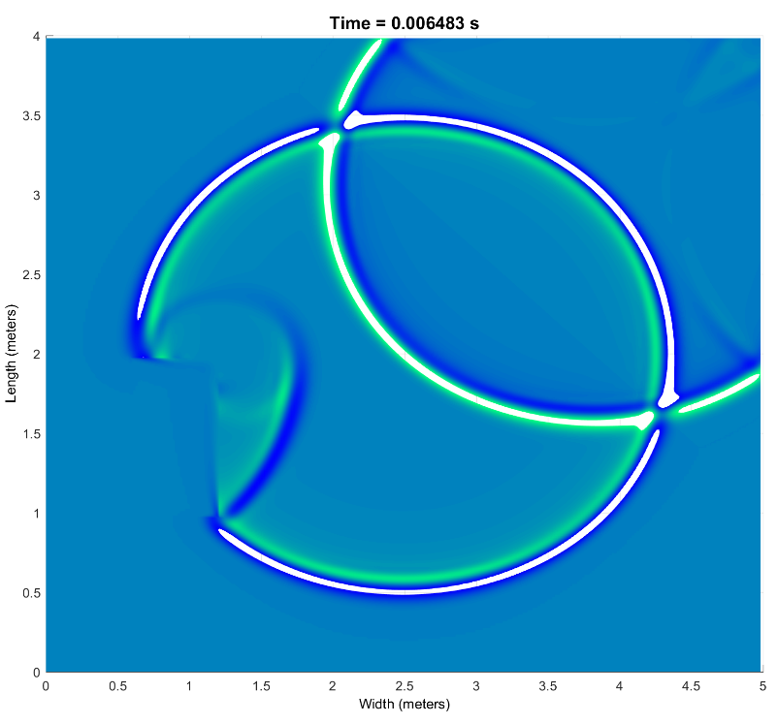

Figure 1Example visual output of an FDTD simulation of reflection behavior with two sound sources and a single obstacle in an almost anechoic domain [1]

One of the early proponents of work on time domain numerical methods for acoustic simulation was Bootledooren[2]; whose work involved porting the finite difference time domain (FDTD) and finite volume time domain (FVTD) methods from electromagnetic simulation to acoustics, to use in low frequency acoustic simulation. This work has been followed on by many researchers such as Murphy[3], Bilbao[4], Savioja[5] and Hamilton[6], to expand and improve potential use of these methods.

Despite a mature body of supporting work, high frequency and large domain simulations using finite difference methods are still uncommon. Work was undertaken focused on combining finite difference and ray based methods to simulate large domains[7], but few commercial products have utilized this research. In his doctoral thesis[8], one of the authors presented a simple and effective implementation of the FDTD method for low frequency modelling, that was the basis for the work presented in this paper.

Following key work such as that by Trefethen[9], a number of wave modelling projects have begun to explore the Fourier pseudo-spectral time domain method (PSTD), most notably the OpenPSTD project from Eindhoven University of Technology[10]. Caunce and Angus[11] recognised the limitations of implementing the FDTD method on general purpose graphical processing units (GPGPU) that can be used to improve the speed of FDTD solving; and introduced potential improvements in execution speed by performing spectral differentiation on a GPGPU by using the Fourier PSTD method. The early work by Caunce and Angus study was the basis for the PSTD solver in this study.

In the field of microcontroller development, Doerr[12]–[14] produced work on the spare finite difference time domain method for electromagnetic simulation. PIC microcontrollers are often modelled as vastly large electromagnetic simulations of networks of channels that take large computational resources and a lot of time to simulate. Doerr suggested that a large proportion of the microcontroller domain being simulated is made of a dielectric material and is not necessary for the purpose of the simulation; it should therefore be possible compute only parts of the domain around electromagnetic waves and reduce computation time. The sparse finite difference time domain method presented by Doerr essentially uses a moving window method for reducing the size of the portion of the domain being solved at any one time.

Methods such as FDTD present benefits for low frequency simulation over other simulation methods such as ray based and direct calculation, as features such as the modal behaviour of the acoustic system being modelled is accounted for within the model. This is due to solving the acoustic wave equation in second order partial differential form; ray based methods assume planar radiation of sound waves, and ignore the radial propagation and resonance of the systems being modelled.

Regardless of the time domain method used for solving a simulation, it should be possible to setup and solve a simulation in reasonable time and without requiring specialist computing equipment. The aim of this paper is to explore the potential improvements of execution speed of the PSTD and SFDTD methods, over the FDTD method. In the following section of this paper, a series of simulation test cases are described. Following this, the results of the acoustic output and the execution speed of the simulation methods are compared. Finally, the execution speed profile of each method is reviewed, highlighting where the speed bottlenecks occur in each method.

## Background

Large scale and high frequency simulations are often difficult to perform using time domain methods, not only because of the large computational resources required to perform the simulations; the time required to perform these simulations can also be severely limiting. This is due to the requirement to equally represent discretisation of the entire domain, and the various conditions for accuracy and stability that must be met when solving partial differential equations numerically. These conditions can be difficult to overcome, but if it is possible to reduce the execution time (and ideally the memory requirements) of a simulation; using time domain numerical methods could become more accessible for less academic users such as sound engineers, loudspeaker designers and undergraduate students.

The basic FDTD method for solving acoustic models involves representing an acoustic system such as a room, as a set of matrices that represent points of pressure and points of velocity within the fully discretised system. The conceptual distance between the points in the system is defined by the stability of the equations being solved, the physical properties of the system and the highest frequency of interest. A wave equation is split up into two reciprocating parts, using velocity points to calculate surrounding pressure points, and pressure points to calculate surrounding velocity points. This is performed in a leapfrog fashion in steps over time, the conceptual length of the step is also determined by the highest frequency of interest and the stability or the solving method.

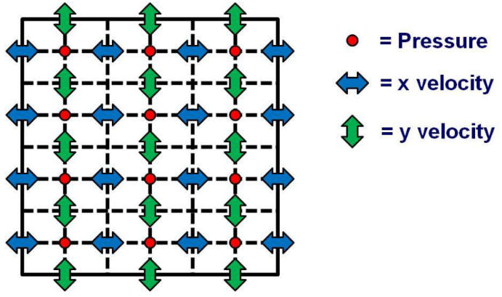

Figure 2 Generic 2D FDTD stencil [8]

The Courant-Freidrichs-Lewey[15] (CFL) condition is a condition that dictates the minimum length of time step and spatial step required for a convergent solution, when using a time stepping method to solve a set of partial differential equations. The equation for Courant number in the one-dimensional case is given below:

Equation 1 CFL stability condition for 1D wave travel

The maximum value of is determined by the stability of the method being used to solve the PDE, and for a simple explicit FDTD simulation is typically 1. Following Nyquist sampling theorem, the maximum spatial step in an FDTD simulation is tough anecdotal discussion and some literature suggests between and is a better target range for a simulation spatial step that is likely to provide reasonable results. Simulating an arena that is 60 m x 40 m x 30 m large, up to a frequency of 500Hz may require 48,326,250 points in the pressure and each velocity matrix. Rearranging the above equation for the maximum time step in a 3D simulations gives[16]:

Equation 2 Maximum time step with respect to wave speed for a 3D simulation based on the CFL condition

This time step equates to 92 total solving steps for one second worth of simulation time, indexing into matrices of at least 1.93GB when using the native double precision floating point arithmetic of Matlab. When considering a 3 dimensional simulation, of the arena mentioned above, 8GB of memory could be required for the matrices that describe the domains pressure and velocities. It can be difficult to perform large simulations up to high frequency, as the amount of memory required to perform a simulation can quickly become greater than that available in non-specialist computer systems. The figure below shows the size of each matrix required to perform the simulation for maximum frequencies of between 500Hz and 20kHz.

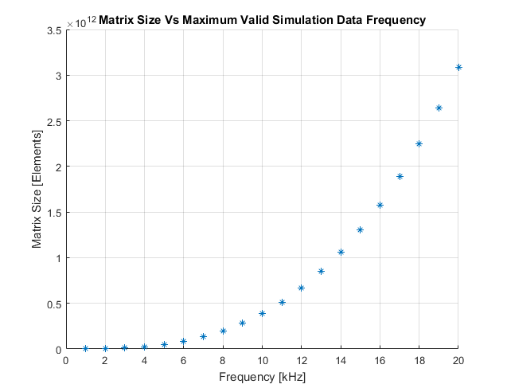

Figure 3 Domain matrix size vs frequency for an FDTD simulation of a 60 m x 40 m x 30 m arena

Another fundamental problem with the FDTD method is the requirement to constantly perform non-contiguous memory accesses to perform calculations. Computer memory access (particularly in the CPU cache) is optimised for contiguous accesses in one direction. The FDTD method can require the system to access memory in an orthogonal direction to the optimum around 50% of the time, and also requires the system to index into two large blocks of memory simultaneously.

Two similar methods to FDTD that may execute faster in some circumstances are the PSTD and SFDTD methods. The PSTD method follows a similar form to the FDTD methods in most respects. The main difference is that differentiation in the method is performed in the frequency domain; each domain matrix is multiplied by the impulse response of an ideal differentiator in the frequency domain, before being used to calculate the new values of the reciprocating field. While this method has the potential to be much faster than FDTD by leveraging the speed of optimised memory access and discrete Fourier transforms, this method requires a perfectly matched layer (PML) to overcome Gibbs phenomenon and can suffer from aliasing due to the non-periodic nature of the system being simulated[17]. A PML is a boundary layer surrounding the computational domain that is non-reflective at any frequency or angle of incidence, the theoretical reflection factor of which is that of a vacuum and absorbs all energy that enters the boundary layer[18].

The SFDTD method involves windowing around the portions of the domain that are above a threshold of energy. This window is then used as a guide, and only the necessary portions of the domain are computed. This method is still very much in early development in acoustics, and little literature is available in acoustics circles that have explored this method. As such a robust and well validated implementation of SFDTD in acoustics has yet to be reported. Further, the method may only be useful for speed improvements before the level of the diffuse field is relatively high i.e. when the early strong reflections are propagating across the domain. This method would also ideally use a high order FDTD stencil that doesn’t suffer as distinctly from numeric dispersion as the 2nd order stencil [19], [20].

# Implementation Experiment

In order to test the execution speed of the FDTD, PSTD and SFDTD methods, all three were implemented as sets of functions in Matlab. Code development and speed testing was executed on a PC with the following characteristics:

Operating System: Windows 10

CPU: i5 4960k Overclocked to 4.5GHz and 1.227V

RAM: 16GB DDR3 ram at 3875 MHz

Motherboard: Asus Gryphon Armour Edition with Z97 chipset

GPU: Nvidia GTX 1070

This computer system uses standard, easily available consumer grade parts and was configured using inbuilt automatic tools, thus requiring little specialist configuration knowledge.

Initially the FDTD solving method was implemented as a function, based on previous work by one of the authors [8]. First a 2D version, and then a 3D version was implemented. The differentiation in the FDTD method is performed by indexing into discrete points of pressure and velocity potential matrices, and calculating new local values of each based on the old and surrounding values of the related variable at each point in the domain. Following this, a test was executed to check that a stimulus is propagated across the domain without great distortion, spectral shifting or unstable behaviour. The domain setup was a 5 m x 4 m x 3 m rectangle, and had partially absorbing boundaries with an absorption coefficient of 0.45. The maximum analysis frequency was 5kHz. Stimuli used were three sets of 10 cycles of 1kHz windowed tone burst, with a rest period of 3 times the length of the tone. Each stimulus lasted for 0.1s, following which there was 0.1s of silence to allow for decay of the reverberation. The signal source was positioned as close to 1 m away from a corner of the domain as possible. Five points of the domain (near the corners and the centre) were ‘recorded’ for the length of the simulation.

Figure 4 below shows the normalised source and receiver signals in the time domain, and in the frequency domain using Welch’s power spectral density estimation method built into matlab.

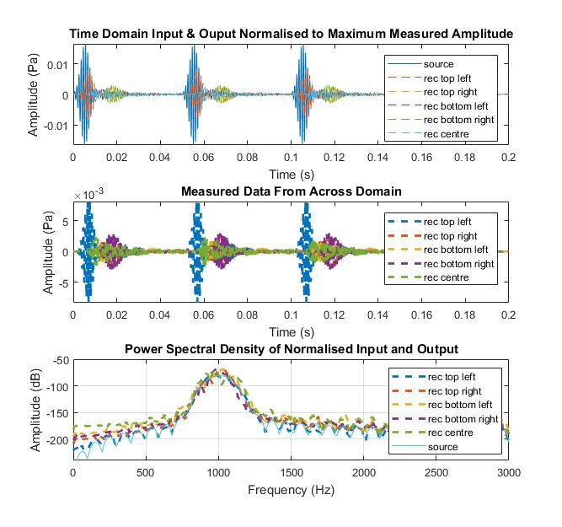

Figure 4 Response of a FDTD simulation 1) Stimulus vs measured signals (normalized) 2) Time domain response at different positions in the domain 3)Smoothed frequency domain representation of the measurements at each position in the domain

The output shows that the frequency of the propagations across the domain is the same as the stimulus, and no high amplitude oscillatory components are present. The time domain behaviour of the simulation appears to show sensible propagation delay between measurement points, with decay that would suggest the simulation is convergent. Using the inbuilt code profiler tools in Matlab, it was possible to analyse the performance of this FDTD implementation and determine where the bottlenecks are. Figure 5 below shows the Matlab profiler output of analysis of the 3D FDTD solving code.

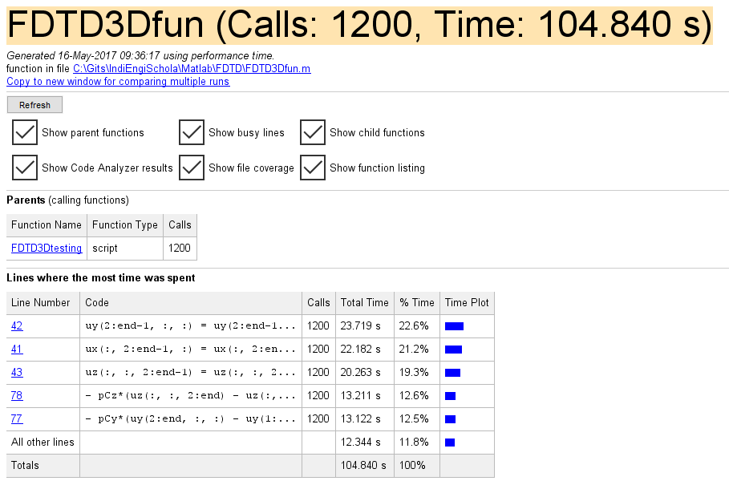

Figure 5 3D FDTD execution code profiling

The slowest parts of this FDTD implementation are the parts where the differentiation is occurring i.e. where the system is having to perform multiple memory accesses to separate large matrices. Managing or reducing these accesses may help speed up solving.

The PSTD method was implemented as a set of Matlab functions in a similar way to the FDTD method, and was based on the work by Caunce & Angus[11]. To implement partially absorbing boundary conditions, work by Spa *et al* [21]. The differentiation in the PSTD method is performed by performing a discrete Fourier transform on 1 dimension of the domain, and multiplying the frequency domain spatial data with the impulse response of an ideal differentiator. The inverse discrete Fourier transform of the differentiated spatial domain data is then used to calculate the new values of the reciprocating field. The differentiation is performed singularly in all spatial dimensions of interest. This method of differentiation may be preferential to the FDTD method, because the differentiation for calculating any one point includes differentiation of all points in the domain that are linearly coupled.

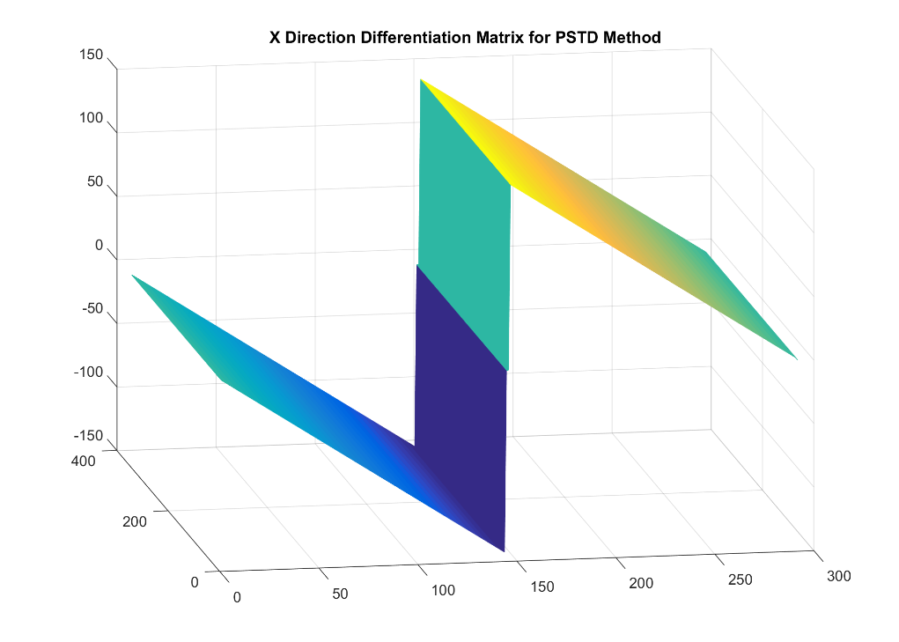

Figure 6 Differentiation matrix for a 2D PSTD simulation on the real axis, differentiating in the x dimension

This not only increases the order of accuracy of the method, but use of optimised libraries for the Fourier transform and vectorisation can be leveraged by the compiler, to increase the speed of computations for differentiation. The same simulation test as that described above for the FDTD method was used with the PSTD implementation, with a maximum frequency of 5kHz instead of the 2kHz of used for the FDTD simulation. The figure below shows the output of the method in the same format, with the third plot adjusted for a higher maximum frequency.

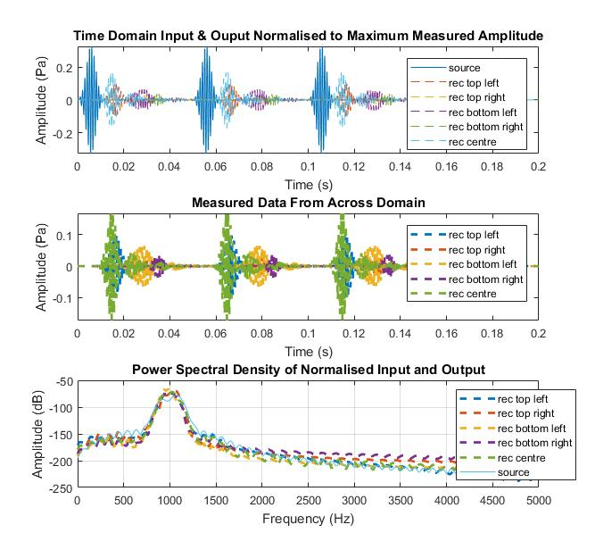

Figure 7 Response of a PSTD simulation 1) Stimulus vs measured signals 2) Time domain response at different positions in the domain 3) Smoothed frequency domain representation of the measurements at each position in the domain and the stimulus

The frequency domain response of the system gives a centre frequency of wave propagation at 1kHz, the same as the stimulus tone. The width and shape of the window is similar to that from the FDTD simulation, but with a spectral tilt leaning toward a low pass behaviour. The rate at which the propagating wave reached receivers appears to be different to the results from the FDTD simulation, suggesting that the wave speed is different between the two simulations. Further work could be undertaken to diagnose this discrepancy, but it would appear that the overall performance of the system is acceptable enough to use this algorithm for speed testing.

The SFDTD method was implemented as a set of Matlab functions, based on the same work by Hill mentioned above, and with inspiration from the work of Doerr [12]. Though Doerr’s work in computational electromagnetics is interesting, it uses a list based method for accounting for window shape and position is perhaps not appropriate for an elastic wave system where a diffusely fluctuating field is desirable for calculation. The approach taken for implementing SFDTD in this study was to create a normalising indexing window, based on the absolute pressure of the domain.

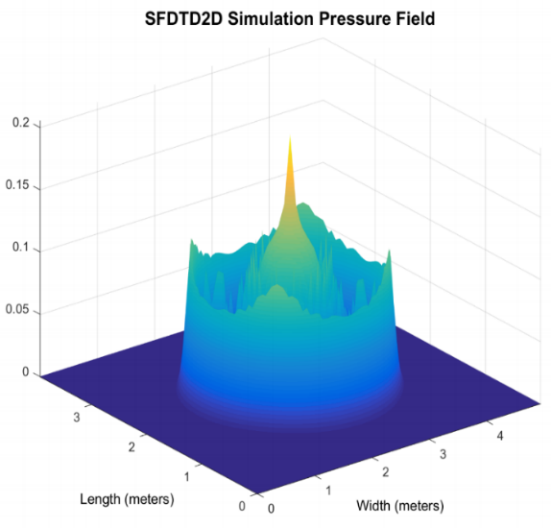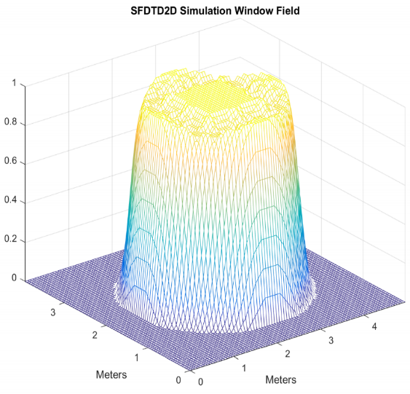

Figure 8 SFDTD 2D 1) travelling stimulus 2)Window function

The normalised shape of the domain (around a threshold) was then smoothed using a Gaussian image filtering technique, to ensure that the window surrounding points of high enough pressure within the domain are also used for differentiation. This allows wave fronts to propagate naturally across the domain unimpeded by the window itself. The window is used to restrict the number of points within the domain that are calculated, to those around which there is sufficient energy. Due to time constraints with this study, little work was done to optimise the threshold value and 40dB was used throughout the study. Further work should be undertaken to determine ideal smoothing window shapes and threshold values. The next step was to solve the example test using the SFDTD method. The results are displayed below.

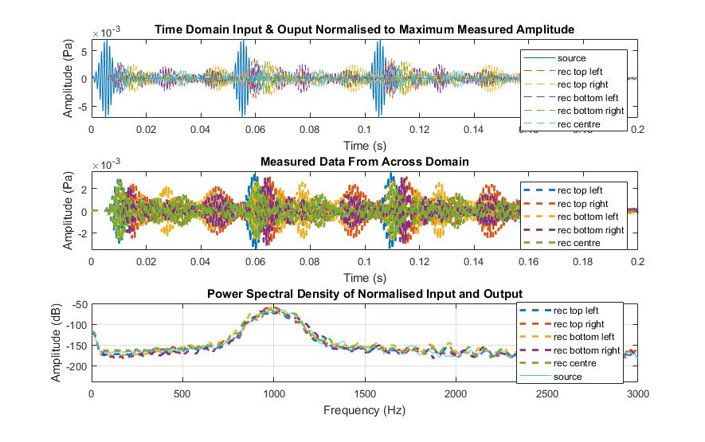

Figure 9 Response of a SFDTD simulation 1) Stimulus vs measured signals 2) Time domain response at different positions in the domain 3) Smoothed frequency domain representation of the measurements at each position in the domain and the stimulus

Due to much of the configuration being identical to the FDTD implementation, the results of the SFDTD simulation were quite similar to the FDTD solution. Same set of domains and maximum frequency used for reasonable comparison. The amplitude of the reflected wave fronts, at least for early reflections are relatively high compared to the threshold of the window.

The figure below shows the computation time transition for a set of 2D simulations using the SFDTD method.

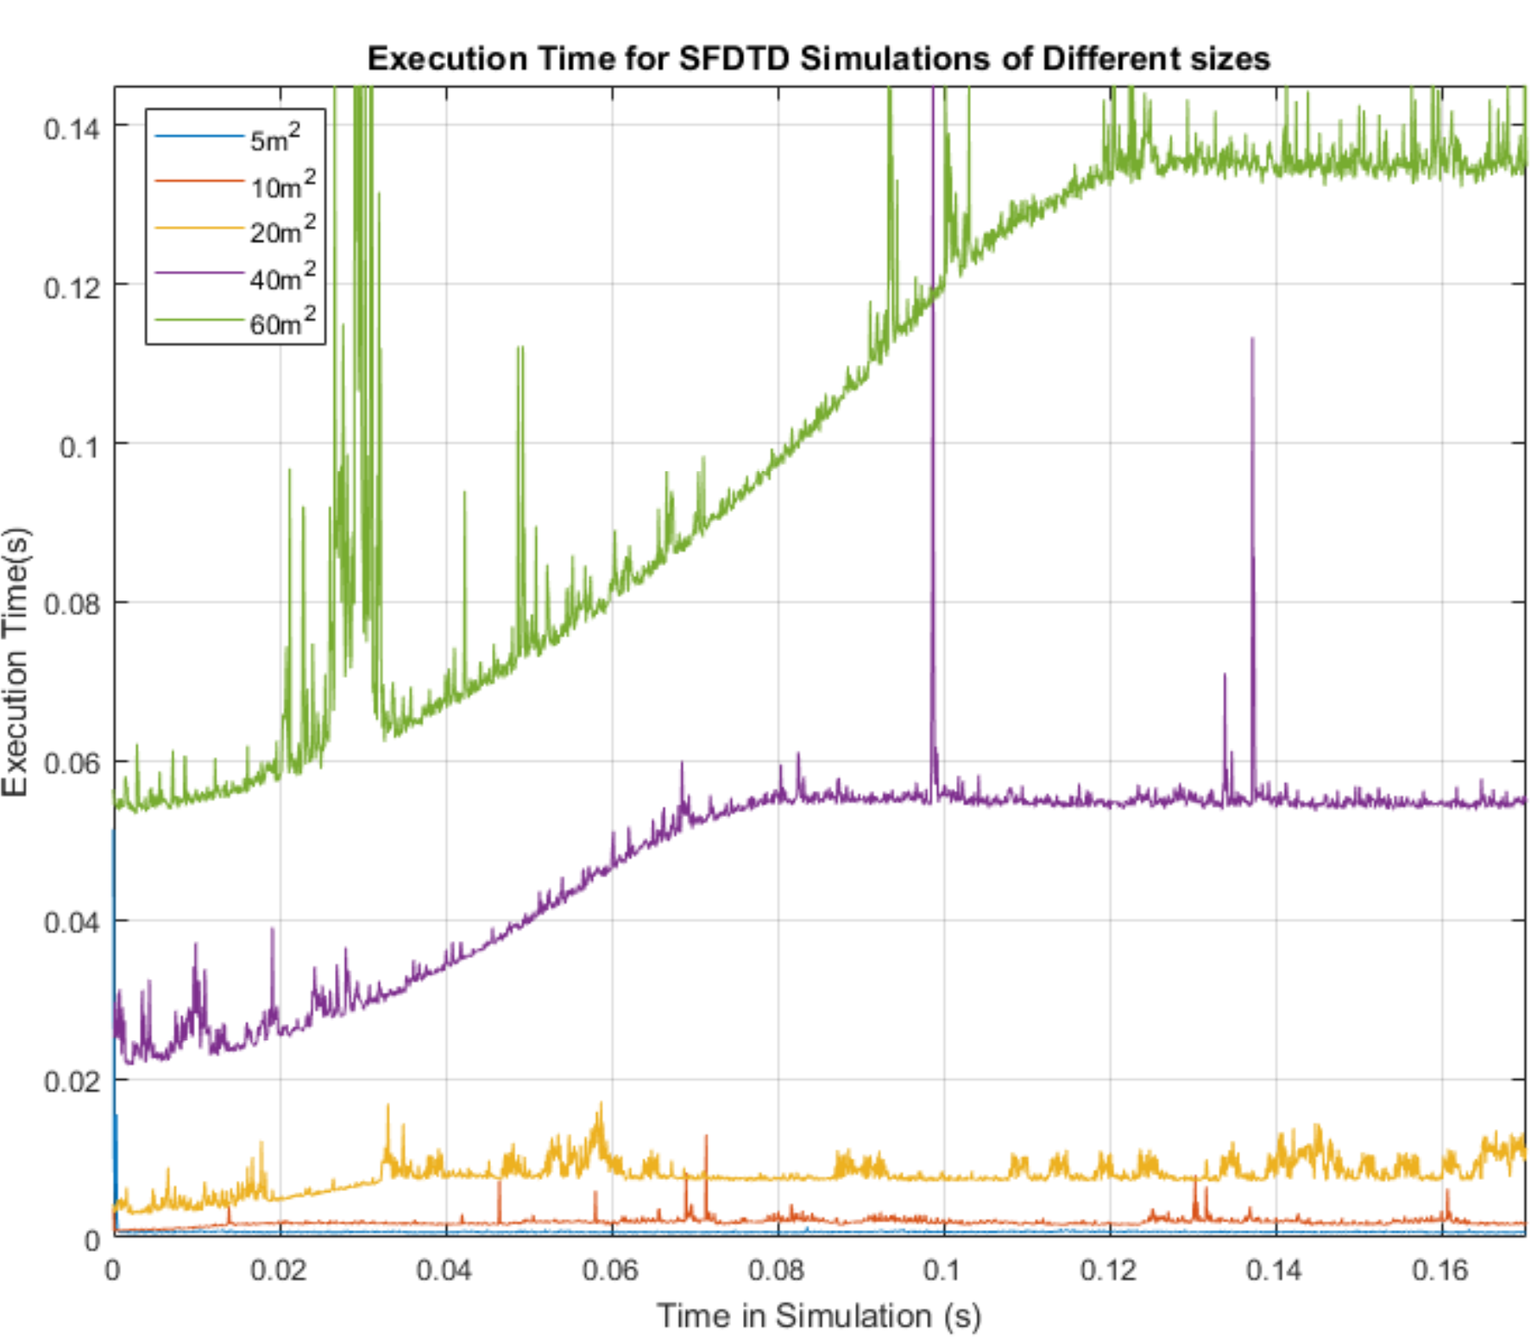

Figure 10 2D SFDTD execution time per time step for a range of domain sizes

This figure highlights the behaviour of the SFDTD method, reducing early computation times before a steady state diffuse field is calculated. Using this method to reduce computation time may be appropriate when calculating the early reflection behaviour of the acoustic system, when the wave fronts that are propagating are distinct.

# SPEED TEST EXPERIMENT

To examine the execution speed performance of each time domain method, each method was used to solve a series of increasingly large rectangular 3D domains. The execution speed for each of the 2000 time-step iterations of each method was measured using the inbuilt Tic/Toc functionality of Matlab. A set of 5 domain sizes were used, the size and number of cells for each time domain method are given in table 1.

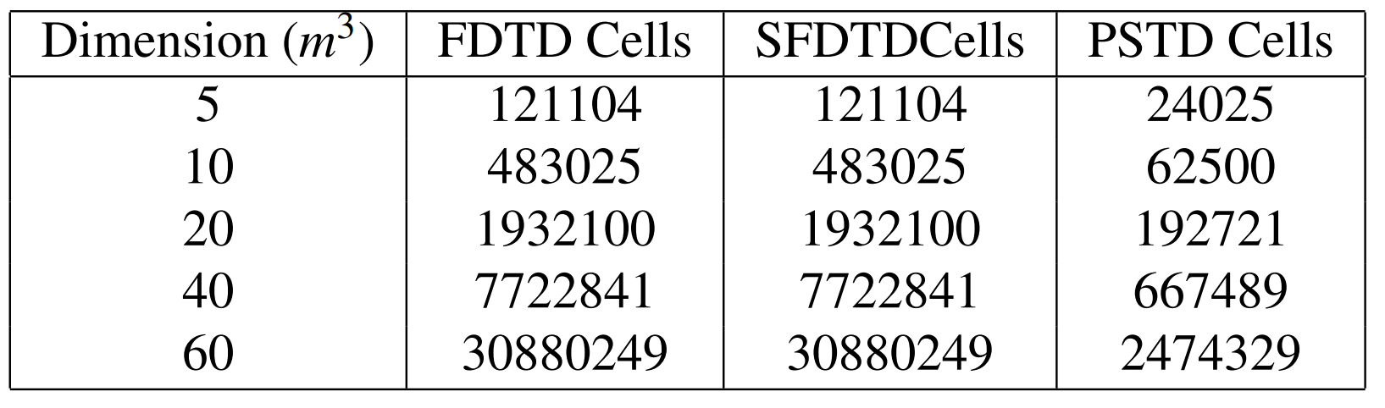

Table 1Set of domain sizes and domain cells for each time domain method

These domain sizes were chosen by choosing a scaling factor up to the maximum domain size and variables that could fit in the computer’s memory. Ideally, some future work on very large domain sizes would handle temporary data storage in binary files on hard-disk, allowing a simulation system to only have necessary large files in memory at any one time. The PSTD domains appear to require significantly fewer cells than the S/FDTD methods, this is due to the nature of stability in the PSTD method. As PSTD differentiation is undertaken using all linearly contiguous cells, the order of the differentiation is higher than that of FDTD and fewer points per wavelength are required for frequency domain accuracy [22].

When running each simulation with the different time domain methods, the supporting code around the simulation kept a similar format and only the execution of the time step solving was measured. No plotting was performed during the speed tests; due to the single threaded nature of internal engine of Matlab, this would have significant performance implications on the overall speed of the simulation execution. The maximum frequency of interest for the simulations was 500Hz, which was chosen due to the size constraints of arrays in memory as per the domain sizes described above.

## Results

The two figures below show the mean time step execution speed for each time domain method and domain size. The first figure shows time on a linear scale, and the second figure shows time on a logarithmic scale.

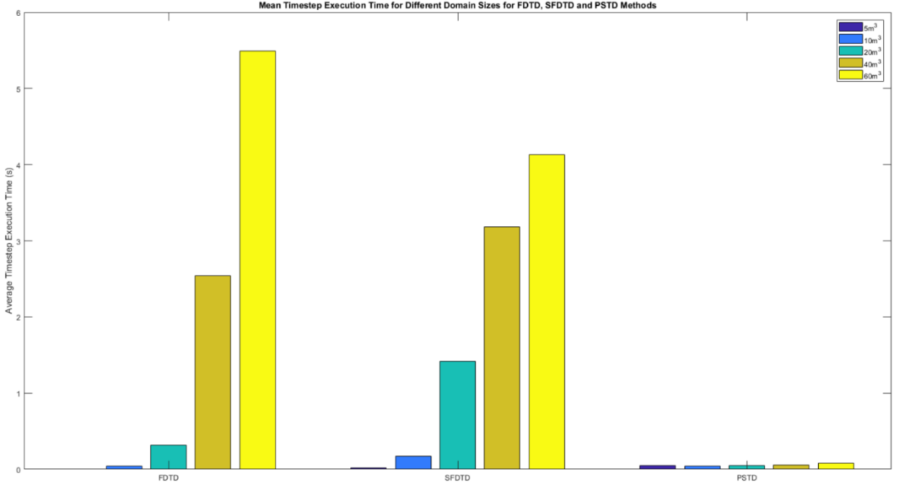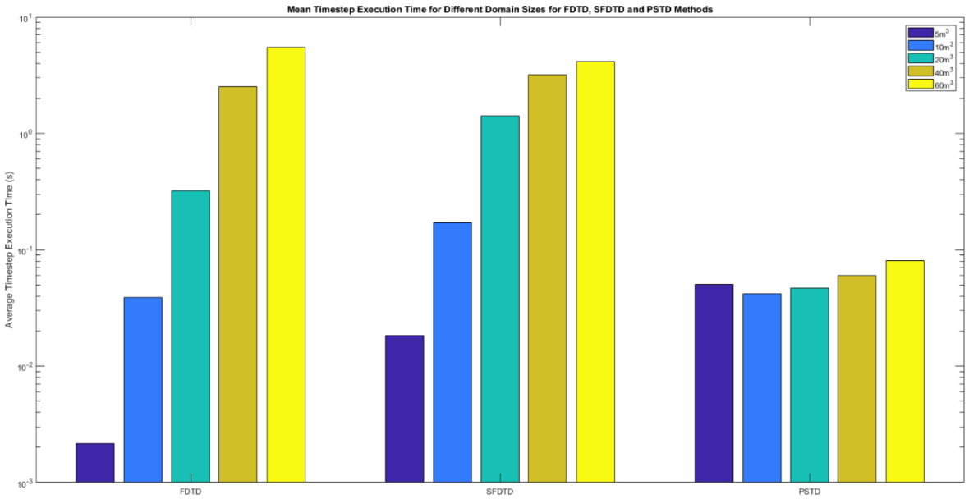

Figure 12 Mean time step execution time for each method and for a range of domain sizes on a linear scale

Figure 11 Mean time step execution time for each method and for a range of domain sizes on a log scale

These results would suggest that the PSTD method gives significantly faster execution times than the FDTD and SFDTD methods. This may be because of both the utilization of optimised computation methods, and the relaxed domain attributes required for a simulation i.e. requiring smaller array sizes than the FDTD and SFDTD methods to simulate large domains up to higher frequencies. However, implementing partially absorbing boundary conditions, handling obstacles, and minimizing aliasing may be non-trivial work, where the FDTD and SFDTD methods may be easier to modify and scale for different problems.

The results also show that the SFDTD method reduced average computation times only with the largest domain size, and increased computation time for all other domain sizes. This is probably due to the non-optimised implementation of the method and the threshold of the window, as well as the extra number of computations required to create and then reference the window function. As shown in figure 10, before the stimulus has much effect on the domain, the number of extra calculations being undertaken to create the window may be large enough to offset any benefits that such a window might give in terms of total domain used in computation, once wave fronts are propagating across the domain.

# CONCLUSION & Further Work

The results of this study may give an indication of some potential to improve execution speed of time domain methods more generally, when using spectral methods for differentiation. A window based method of reducing domain computation area may improve the execution speed in very large simulations, but further work is required to prove this. The steps of differentiation are likely to be the parts of the time domain methods presented that are slowest. Addressing the speed of differentiation by using different matrix sizes, indexing methods or strategies may improve the execution speed of finite difference methods.

The experiment above may have given some idea as to execution speeds of the methods, but has some significant limitations. The implementations of each method presented are certainly not mature, and required a significant amount of improvement and experimentation to provide high quality results, for both measuring acoustic behaviour and optimal performance. None of the methods presented acoustic behaviour that was easy to validate, and the number of time steps used in the final speed tests were quite small. A change in the initial conditions of the speed tests may well have given very different execution speed results, due to the SFDTD methods window function taking a relatively long time to compute.

While this work shows some good evidence that improvements can be made to the execution speed of time domain finite difference style methods, there is a significant amount of further work required to solidify and validate these results. This work may include, but is not limited to:

* Experimenting with the process of SFDTD window calculation.
* Determining the optimal window threshold for the SFDTD method.
* Experimenting with methods to reduce overall number of points required to represent a domain i.e. domain decomposition.
* Examination and improvement of the output of the Fourier PSTD method, including the performance of the PML and experimentation with the Chebyshev PSTD method
* Investigation into obstacles and better partially absorbing boundary conditions in the PSTD method

Although significantly more work needs to be done to improve the speed of execution of time domain methods, this work shows potential for the improvement of these speeds. Further development of these methods could provide simply scalable and intuitive tools for simulating and analysing acoustic propagation, without the need for specialist computing equipment.

# References

[1] S. Durbridge, “Efficient Acoustic Modelling of Large Spaces using Time Domain Methods Acoustic Modelling Applications,” pp. 1–8, 2017.

[2] J. De Poorter and D. Botteldooren, “Acoustical finite-difference time-domain simulations of subwavelength geometries,” *J. Acoust. Soc. Am.*, vol. 104, no. 3, pp. 1171–1177, 1998.

[3] D. T. Murphy, A. Southern, and L. Savioja, “Source excitation strategies for obtaining impulse responses in finite difference time domain room acoustics simulation,” *Appl. Acoust.*, vol. 82, pp. 6–14, 2014.

[4] S. Bilbao, “Optimized FDTD schemes for 3-D acoustic wave propagation,” *IEEE Trans. Audio, Speech Lang. Process.*, vol. 20, no. 5, pp. 1658–1663, 2012.

[5] L. Savioja, “Real-time 3D finite-difference time-domain simulation of low- and mid-frequency room acoustics,” *Proc Int Conf Digit. Audio Eff.*, pp. 1–8, 2010.

[6] B. Hamilton and S. Bilbao, “Fourth-Order and Optimised Finite Difference Schemes for the 2-D Wave Equation,” *Research.Ed.Ac.Uk*, vol. 2, no. 2, pp. 1–8, 2013.

[7] J. Van Mourik and D. T. Murphy, “Hybrid Acoustic Modelling of Historic Spaces Using Blender,” no. c, 2014.

[8] A. J. Hill, “Analysis , Modeling and Wide-Area Spatiotemporal Control of Low-Frequency Sound Reproduction,” University of Essex, 2012.

[9] L. N. Trefethen, “Spectral Methods in Matlab,” *Lloydia Cincinnati*, vol. 10, p. 184, 2000.

[10] M. Hornikx, T. Krijnen, and L. Van Harten, “OpenPSTD: The open source pseudospectral time-domain method for acoustic propagation,” *Comput. Phys. Commun.*, vol. 203, pp. 298–308, 2016.

[11] J. A. S. Angus and A. Caunce, “A GPGPU Approach to Improved Acoustic Finite Difference Time Domain Calculations,” in *128th Audio Engineering Society Convention*, 2010.

[12] C. Doerr, “SPARSE FINITE-DIFFERENCE TIME DOMAIN SIMULATION,” US 2014/0365188 A1, 2014.

[13] C. Doerr, “Sparse Finite Difference Time Domain Method,” *IEEE Photonics Technol. Lett.*, vol. 25, no. 23, p. 1, 2013.

[14] C. Doerr, “3D Sparse Finite-Difference Time-Domain Simulation of Silicon Photonic Integrated Circuits,” vol. i, pp. 4–6, 2015.

[15] S. Bilbao, *Wave and Scattering Methods for Numerical Simulation*, 1st ed. London: John Wiley & Sons, 2004.

[16] K. Kunz and R. Luebbers, “The Finite Difference Time Domain Method for Electromagnetics.” p. 464, 1993.

[17] C. Spa, A. Garriga, and J. Escolano, “Impedance boundary conditions for pseudo-spectral time-domain methods in room acoustics,” *Appl. Acoust.*, vol. 71, no. 5, pp. 402–410, 2010.

[18] J. P. Berenger, “A perfectly matched layer for the absorption of electromagnetic waves,” *J. Comput. Phys.*, vol. 114, pp. 185–200, 1994.

[19] J. Van Mourik and D. Murphy, “Explicit higher-order FDTD schemes for 3D room acoustic simulation,” *IEEE/ACM Trans. Speech Lang. Process.*, vol. 22, no. 12, pp. 2003–2011, 2014.

[20] B. Hamilton and S. Bilbao, “Fourth-Order and Optimised Finite Difference Schemes for the 2-D Wave Equation,” *Research.Ed.Ac.Uk*, vol. 2, no. 2, pp. 1–8, 2013.

[21] C. Spa, J. Escolano, and A. Garriga, “Semi-empirical boundary conditions for the linearized acoustic Euler equations using Pseudo-Spectral Time-Domain methods,” *Appl. Acoust.*, vol. 72, no. 4, pp. 226–230, 2011.

[22] M. Hornikx, R. Waxler, and J. Forssén, “The extended Fourier pseudospectral time-domain method for atmospheric sound propagation.,” *J. Acoust. Soc. Am.*, vol. 128, no. 4, pp. 1632–46, 2010.